**Skeleton Guidance on Appropriate Usage of Family Context**

**Purpose**

The purpose of this document is to propose the guidance to be provided to area social workers on the appropriate usage of the Family Context tool. This proposal should be developed to align the usage of the tool with existing social work practice as much as possible.

**Background**

The guidance proposed in this document should be shaped and approved by service leadership and Information Governance in your local authority. Please identify the measures that you will need to take in order to do this:

__________________________________________________________________________________

______________________________________________________________________________________________________________________________________________________________________________________________________________________________________________________

**Consent**

From our experience working with different local authorities, we have learnt that ‘consent’ carries different meanings to social workers and information governance professionals. Below is our understanding of how consent is defined by each party. Please ensure that these definitions apply to your local authority and make any necessary amendments.

To information governance professionals, [consent](https://ico.org.uk/for-organisations/guide-to-data-protection/guide-to-the-general-data-protection-regulation-gdpr/lawful-basis-for-processing/consent/) is one of several possible lawful bases for processing personal data. Consent is **not** the lawful basis for the usage of Family Context when conducting a child and family assessment. Rather, the lawful basis for usage of Family Context is [legal obligation](https://ico.org.uk/for-organisations/guide-to-data-protection/guide-to-the-general-data-protection-regulation-gdpr/lawful-basis-for-processing/legal-obligation/) and [public task](https://ico.org.uk/for-organisations/guide-to-data-protection/guide-to-the-general-data-protection-regulation-gdpr/lawful-basis-for-processing/public-task/).

However, consent is important to have before starting a child and family assessment under section 17 of the Children’s Act and is an important consideration for social workers when they think about appropriate usage of Family Context. This is important as we create guidelines.

**Summary of proposed guidance for using the Family Context tool**

**When a social worker has been assigned to conduct a child and family assessment, do social workers need to have a consent conversation with that family before they use Family Context?**

* We recommend that this is not required for section 47 cases.
* Please state the requirement for section 17 cases: _____________________________________

______________________________________________________________________________________________________________________________________________________________

**In cases where they should have a consent conversation, who should that be with?**

* We recommend that current practice maintained. Please state what current practice stipulates: _____________________________________________________________________________________________________________________________________________________________________________________________________________________________________________

**How should social workers have that consent conversation, what should parents/carers be told?**

* We recommend that current practice maintained. Please state what current practice stipulates: _____________________________________________________________________________________________________________________________________________________________________________________________________________________________________________

**Which individuals can a social worker view information on in Family Context?**

* This will depend on the user journey selected. In user journey 1, you may wish to define this as ‘any individual the social worker believes is relevant to the assessment they are conducting’. In user journey 2, the social worker can view information on any individuals which are recorded as linked to the child on the Case Management System.

**How can social workers use the information presented in Family Context?**

* We recommend social workers use the information to assist them as they conduct the assessment. This includes the following activities:
* Call services and speak to practitioners
* Speak to other individuals relevant to the case
* Share information with other services
* Record any information from the tool or from the resulting conversations in the Case Management System

Please ensure this applies to your local authority and make any necessary amendments.

**Guidance according to the screens shown in the tool**

The following part of this guidance should show the screens a social worker sees in the Family Context tool according to a local authority’s chosen user journey and development of the tool. Alongside each screen, there should be clear guidance on whether a social worker is required to have had the consent conversation before viewing it. Screens 1 and 2 are shown as an example. Please update these screens and complete the guidance for any subsequent screens.

**Screen 1:** Social workers search for a child/individual (delete as appropriate) who is, or is relevant to, the subject of a referral.

**Consent conversation required to view this screen?**

* We recommend that this is not required for section 47 cases.
* Please state the requirement for section 17 cases: _____________________________________

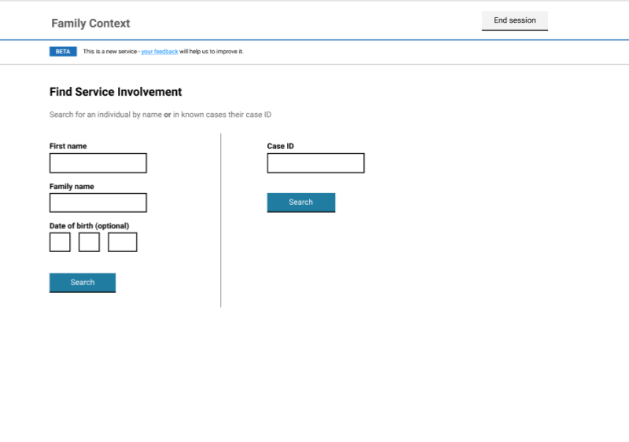______________________________________________________________________________________________________________________________________________________________

**Screen 2:** Social workers select the appropriate individual from a list of matches. Please update the screen according to the chosen user journey in your local authority.

**Consent conversation required to view this screen?**

* We recommend that this is not required for section 47 cases.
* Please state the requirement for section 17 cases: _____________________________________

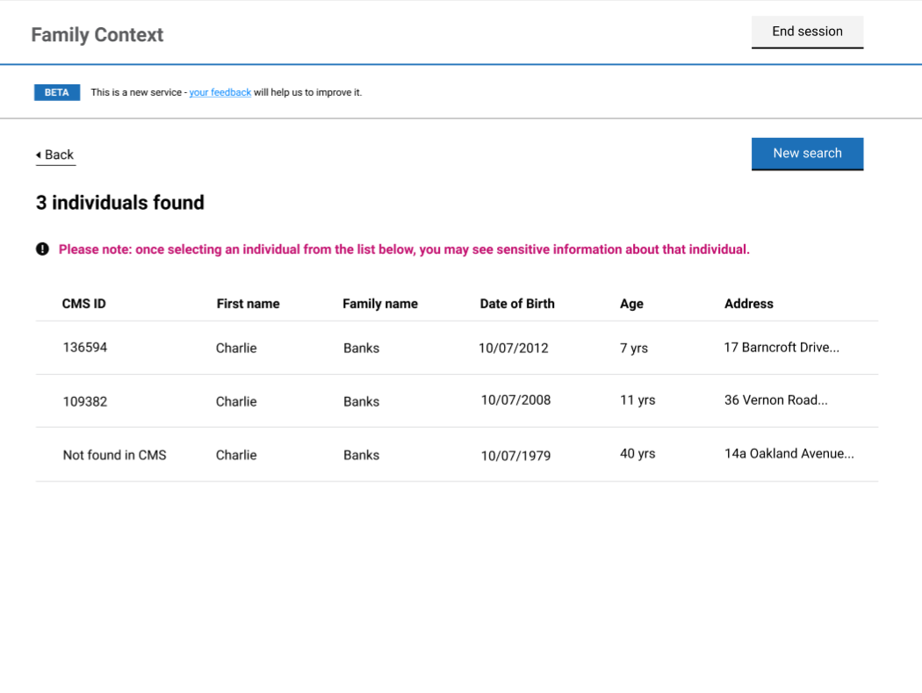______________________________________________________________________________________________________________________________________________________________

**Subsequent screens**

We suggest mirroring the format shown for screens 1 and 2 for the additional screens. We do not include these here because the screens will differ depending on the user journey selected.

Irrespective of the user journey selected, the screens showing an individual’s service involvement should be separated into those showing service involvement *flags* and service involvement *details*.

As part of the guidance on these screens, it is important to list the ages which determine if the service involvement information for a given service appears. For example:

|  |  |
| --- | --- |
| Service | Service section is shown for individuals aged |
| School | 4 - 20 years old |
| Adult Social Care | 16 years old and over (update according to your local authority) |
| Housing | 16 years old and over (update according to your local authority) |
| Police | 18 years old and over |

**Proposal for audit log**

The intention is for the tool to have an audit log that enables team managers and service leads to able to audit Family Context tool and investigate any misuse of tool by social workers.

We propose that team managers and service leads can audit the tool at four different levels:

1. **Audit searches performed by Social Worker.** Team managers and service leads should be able to track searches performed by Social Workers including the date and time of the search, search details and name and ID of the social worker.
2. **Audit search results presented to Social Worker.** Team managers and service leads should be able to track the search results presented to Social Workers including the date and time of in which search results were presented, individual details of people presented to SWs and name and ID of the social worker.
3. **Audit access to details of individual and service involvement flags**. Screen X contains personal details of the individual, as well as service involvement flags. Team managers and service leads should therefore be able to understand when screen X has been seen by social workers, including the date and time in which the information was presented as well as the name and ID of the social worker.
4. **Audit access to service involvement details.** Team managers and service leads should be able to understand which service involvement details on screen X have been seen by social workers including the date and time in which the information was presented as well as the name and ID of the social worker.

Please ensure this applies to your local authority and make any necessary amendments.

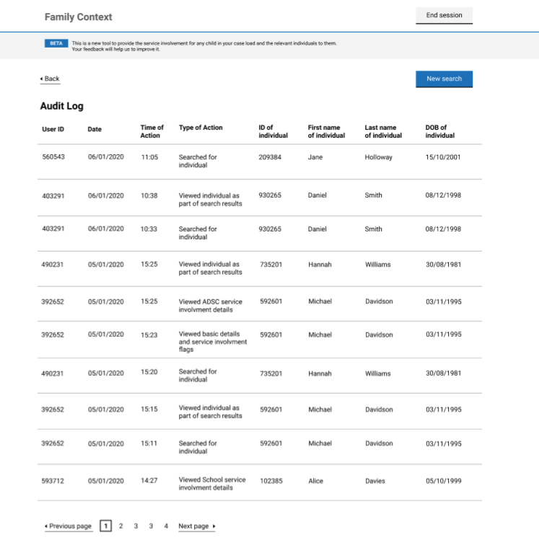It is also helpful to demonstrate what the audit screen will look like in your local authority and list the actions that it captures. Please see the example below and update this according to your local authority.

**Types of actions captured in the audit log**

1) SW searched for individual  
2) SW viewed individual as part of search results  
3) SW viewed basic details about that individual, and service involvement flags  
4) SW viewed School service involvement details  
5) SW viewed Adult Social Care service involvement details  
6) SW viewed Housing service involvement details  
7) SW viewed Police service involvement detail